**Week 5: 03/11/2021 – Wednesday**

1. **Outline of Meeting**

The meeting was carried out on Zoom. The first part of the meeting was dedicated to answering questions and clearing up any misconceptions from the previous week’s topic, the Mattis Bardeen Theory. Following this, the basic concepts of KID microwave readout. In particular, the scattering parameters and the effects it has on microwave circuits. From this, the task for this week was specified which was to create a S21 plots for its amplitude and phase for a range of frequencies. More details on the theory and concepts is given in section 3 of this diary.

1. **Specification of Tasks**
2. Read through the Understanding_Kinetic_Inductance_Detector_Microwave_readout.pdf document on the one drive. Try and create the S21 plots for amplitude and phase. Use the following parameters:

* F0 = 1 GHz
* Qr = 9000
* Qc = 10000

1. **Outline of Theory and Task Methodology**

A schematic of a single pixel on a KID is shown below:

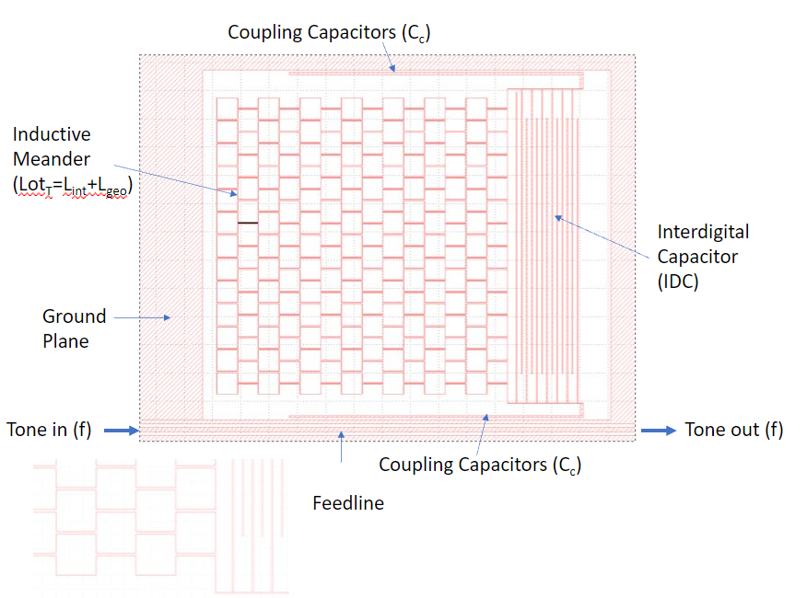

*Source: A schematic of a single pixel on a KID provided by Simon Doyle’s Slides*

The circuit sits on a silicon wafer (white part) and that wafer sits on an aluminium sheet (dashed lines) which is the ground plane. The inductive meander can be characterized as a single inductor with inductance Ltot­. An equivalent circuit is given below:

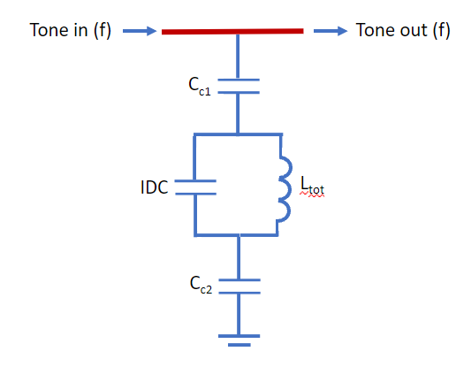

*Source: An equivalent circuit to the schematic of a single pixel on a KID provided by Simon Doyle’s Slides*

The basic mechanism of the circuit is as follows:

Incident photons will provide energy for Cooper pairs to overcome the band gap energy $∆$. As such, the cooper pairs breaks and as a result the density of n1 increases while the superconducting ns density decreases. This increases $σ_{1}$ and as a result, the value of Lint will vary. The dimensions of the inductor does not change, as such will remain constant throughout. Thus, the total inductance L will change accordingly to a change in Lint.

For the capacitors, there are 2 coupling capacitors Cc that couple to the transmission feedline and ground. The total capacitance Cc from Cc1 and Cc2 is simply the series sum:

$$C_{c}=\frac{C_{c1}C_{c2}}{C_{c1}+C_{c2}}$$

The other capacitor is the Intedigital capacitor IDC which is coupled to the Inductive Meander Ltot. We can find the total capacitance of the whole circuit as a simple parallel sum of the capacitances:

$$C_{tot}=IDC+C_{c}$$

The circuit can be modelled as a basic LC circuit with a resonant frequency given by:

$$ω_{0}=\frac{1}{\sqrt{L_{tot}C_{tot}}}$$

Since Ltot varies with respect to photon intensity incident on the inductive meander, $ω_{0}$ varies as well, since the capacitors are coupled to the transmission feedline, therefore the incidence of the photons can be detected, thus a detector. More details on the relationship between incident photon energy and how the detector responds to it will be explored in future meetings and diaries. We have thus crudely characterized a single pixel of a KID.

Another phenomenon faced by the KID:

KIDswork in the microwave frequency range *“Unlike low frequency electronics, working at microwave frequencies typically requires one to treat a signal as a wave rather than simply voltages and currents that one may be used to. This is because at higher frequencies, electronic components become similar in size as the wavelength of the signals being measured.”*

*Source: Understanding_Kinetic_Inductance_Detector_Microwave_readout – Simon Doyle*

Since the wavelengths of the signals being measured is comparable to the length of the wire, it would be useful to be able to characterize the phase at a certain point of the wire. Due to the long wavelength, the phase plays a significant role as some points of the circuit will be out of phase. This is illustrated on the diagram below:

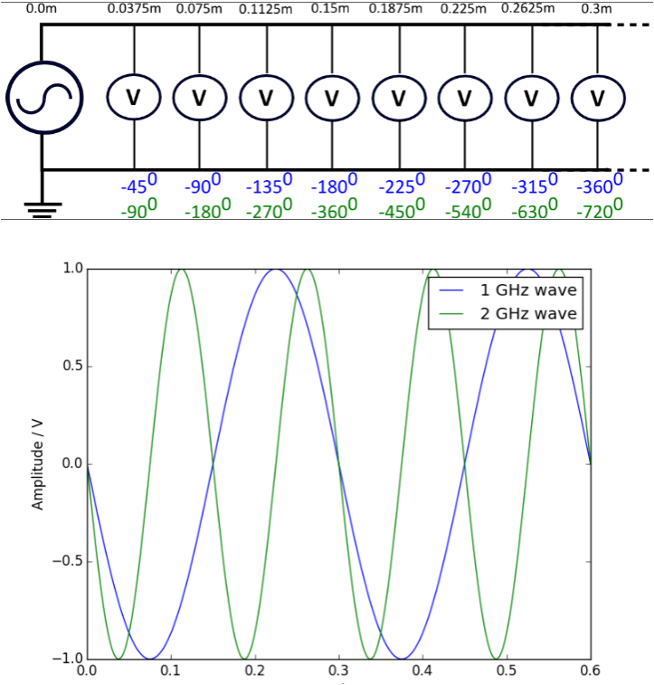

*Source: Understanding_Kinetic_Inductance_Detector_Microwave_readout – Simon Doyle*

Due to this, it is useful to define a microwave circuit in terms of their scattering parameters. These define the voltage waves entering and leaving a microwave circuit via two ports. We denote the scattering parameter as S21 and the S21 for a KID is given as follows:

$$S_{21}=1-\frac{Q_{r}}{Q_{c}}\frac{1}{1+2jQ_{r}x}$$

Where Qc and Qr are known as the coupling Q and resonator Q respectively. These are set by the physical properties of the resonator. J is the complex number -10.5. x is given by:

$$x=\frac{F-F_{0}}{F_{0}}$$

Where F0 is the resonant frequency of the KID and F is the wave propagated along the feedline. Using S21, the Amplitude and Phase of S21 against frequency can be plotted, where:

$$\left|S21\right|=\sqrt{{S21}_{Real}^{2}+{S21}_{Imaginary}^{2}}$$

$${Phase}_{S21}=Arctan(\frac{{S21}_{Imaginary}}{{S21}_{Real}})$$

Where the imaginary and real components of S21 can be found it Python using the following code:

S21_Real = S21.real

S21_Imaginary = S21.imag

As part of the task, the plots of amplitude and phase for S21 against frequency in the bandwidth of 0.0006 GHz with F0 at 1 GHz are given in the following section.

1. **Plots of S21 for Amplitude and Phase vs Frequency**

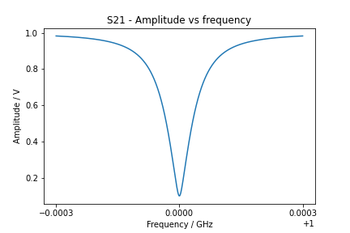

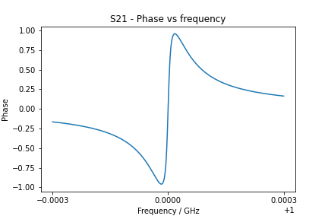

1. **Code For Calculating the Components of S21**

import numpy as np

import matplotlib.pyplot as plt

import cmath as cmath

#Function for calculating S21

def S21(Qr, Qc, f):

x = (f-f0)/f0

result = 1 - (Qr/Qc)*(1/(1+2j*Qr*x))

return result

#Define values

Qr=9000

Qc=10000

f0 = 1e9

#range of frequencies

lower_f = f0-3e5

upper_f = f0+3e5

f = np.linspace(lower_f, upper_f, 1000)

#Compute S21

S21_value = S21(Qr, Qc, f)

S21_real = S21_value.real

S21_imag = S21_value.imag

#Amplitude

plt.figure()

S21_amplitude = (S21_real**2 + S21_imag**2)**0.5

plt.plot(f*10**-9, S21_amplitude)

plt.title("S21 - Amplitude vs frequency")

plt.xlabel("Frequency / GHz")

plt.ylabel("Amplitude / V")

plt.xticks([0.9997, 1.000, 1.0003])

plt.savefig("Amplitude S21 Plot")

#Phase

plt.figure()

S21_phase = np.arctan(S21_imag/S21_real)

plt.plot(f*10**-9, S21_phase)

plt.title("S21 - Phase vs frequency")

plt.xlabel("Frequency / GHz")

plt.ylabel("Phase")

plt.xticks([0.9997, 1.000, 1.0003])

plt.savefig("Phase S21 Plot")